
A10
Sreenidhi Institute of Science & Technology
(An Autonomous Institution)
Code No: 101EC08/111EC08
B. TECH. III – Year II – Semester Examinations, May 2015 (Supplementary)
SIGNALS AND SYSTEMS (EEE)

Time: 3 Hours Max. Marks: 70

Note: No additional answer sheets will be provided.

Part - A
Max.Marks:20

Answer all QUESTIONS.
1. Write analogy between signals and vectors.
2. State and prove time reversal property of Fourier series.
3. Find Fourier transform of an unit impulse function.
4. State frequency convolution theorem of Fourier Transform ?
5. When does aliasing occur? How can it be avoided?
6. State linearity property of Z-Transform?
7. Find the Energy of the signal x(t) = e^{-10t} u(t)
8. Explain the difference between casual and Non-causal systems.
9. Explain the Natural sampling.
10. What do you mean by Gibbs Phenomenon?

Part – B
Max.Marks:50

ANSWER ANY FIVE QUESTIONS. EACH QUESTION CARRIES 10 MARKS.

1. (a) State the condition for orthogonality of real set of signals and show that a rectangular function is orthogonal to signals cos t, cos 2t, …. Cos nt for all integer values of n, over a period 0 to 2π.

(b) Find the exponential Fourier Series of the following signal.
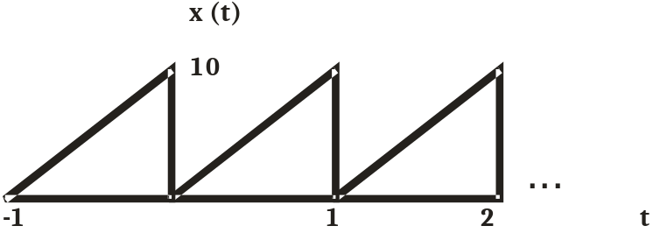

2. State and prove the properties of Fourier series

i) Time shifting property
ii) Conjugate property
iii) Time scaling property
iv) Multiplication property.

3. (a) Derive the relation between Bandwidth and Rise time of Ideal Low pass filter. [6M]

(b) Obtain the conditions for distortion less transmission through a system. [4M]

4. (a) The input and impulse response of a system are given by x(t) = u(t+2) and h(t) = u(t-3) respectively. Determine the output of the system? [6M]

(b) What is auto correlation? State and prove properties of auto correlation of energy signals. [4M]

5 (a) State and prove Sampling theorem for low pass signals.

(b) What is Aperture effect and how the Aperture effect can be compensated?

6 (a) Determine the Laplace transform and region of convergence
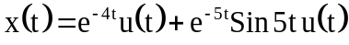

(b) Find the inverse Laplace transform of
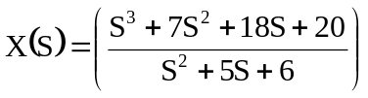.

7 (a) Find the Fourier Transform of the following signals and hence draw the spectrum.
(i) x(t) = A Cos ω_{o}t
(ii) A Sin ω_{o}t
(b) Determine whether the following systems are stable, causal and linear.
(i) e^{x(t)}
(ii) t x²(t)

8 (a) Determine the z-transform of the following sequences ?
(i) x₁(t) = u(-n)
(ii) x₂(t) = n 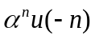
(b) Determine the inverse Z transform of X(Z) = 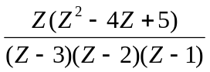 for
i) 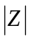> 3 ii) 2 < < 3 iii) < 1

-- 00 -- 00 --

